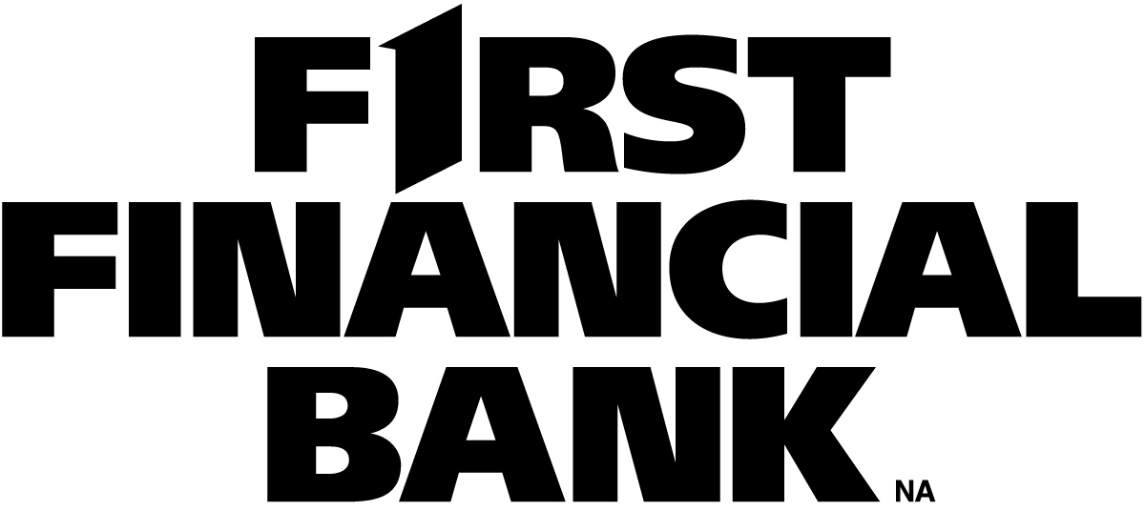
DAI Agency has done a wonderful job for us for years.
Before contracting with DAI Agency, we had to deal with too many sales people taking up too much of our time. They were very hard core sales people and many of our banks spent way too much money when it wasn't even necessary. DAI Agency solved that problem!
DAI Agency saves us a lot of time and money!

